Code:

import pandas as pd

import seaborn as sns

import matplotlib.pyplot as plt

df = pd.read_csv('employee_department_hours.csv')

summary = df.groupby('department').agg(

total_hours=('hours', 'sum'),

average_hours=('hours', 'mean'),

employee_count=('employee', 'count')

).reset_index()

sns.set(style='whitegrid')

plt.figure(figsize=(8, 5))

sns.barplot(data=summary, x='department', y='total_hours', palette='viridis')

plt.title('Total Work Hours by Department')

plt.ylabel('Total Hours')

plt.xlabel('Department')

plt.xticks(rotation=45)

plt.tight_layout()

plt.show()

plt.figure(figsize=(8, 5))

sns.barplot(data=summary, x='department', y='average_hours', palette='coolwarm')

plt.title('Average Work Hours by Department')

plt.ylabel('Average Hours')

plt.xlabel('Department')

plt.xticks(rotation=45)

plt.tight_layout()

plt.show()

max_avg = summary.loc[summary['average_hours'].idxmax()]

print(f"\n Department with Highest Average Working Hours: {max_avg['department']} ({max_avg['average_hours']:.2f} hours)")  
  
Output:

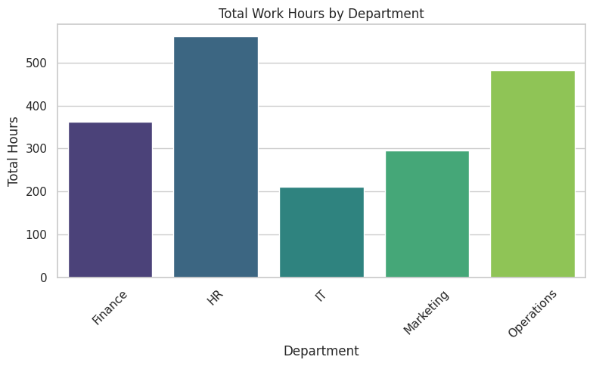  
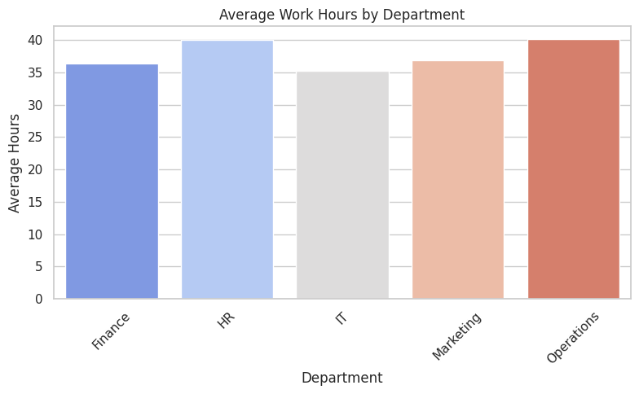  
 Department with Highest Average Working Hours: Operations (40.12 hours)